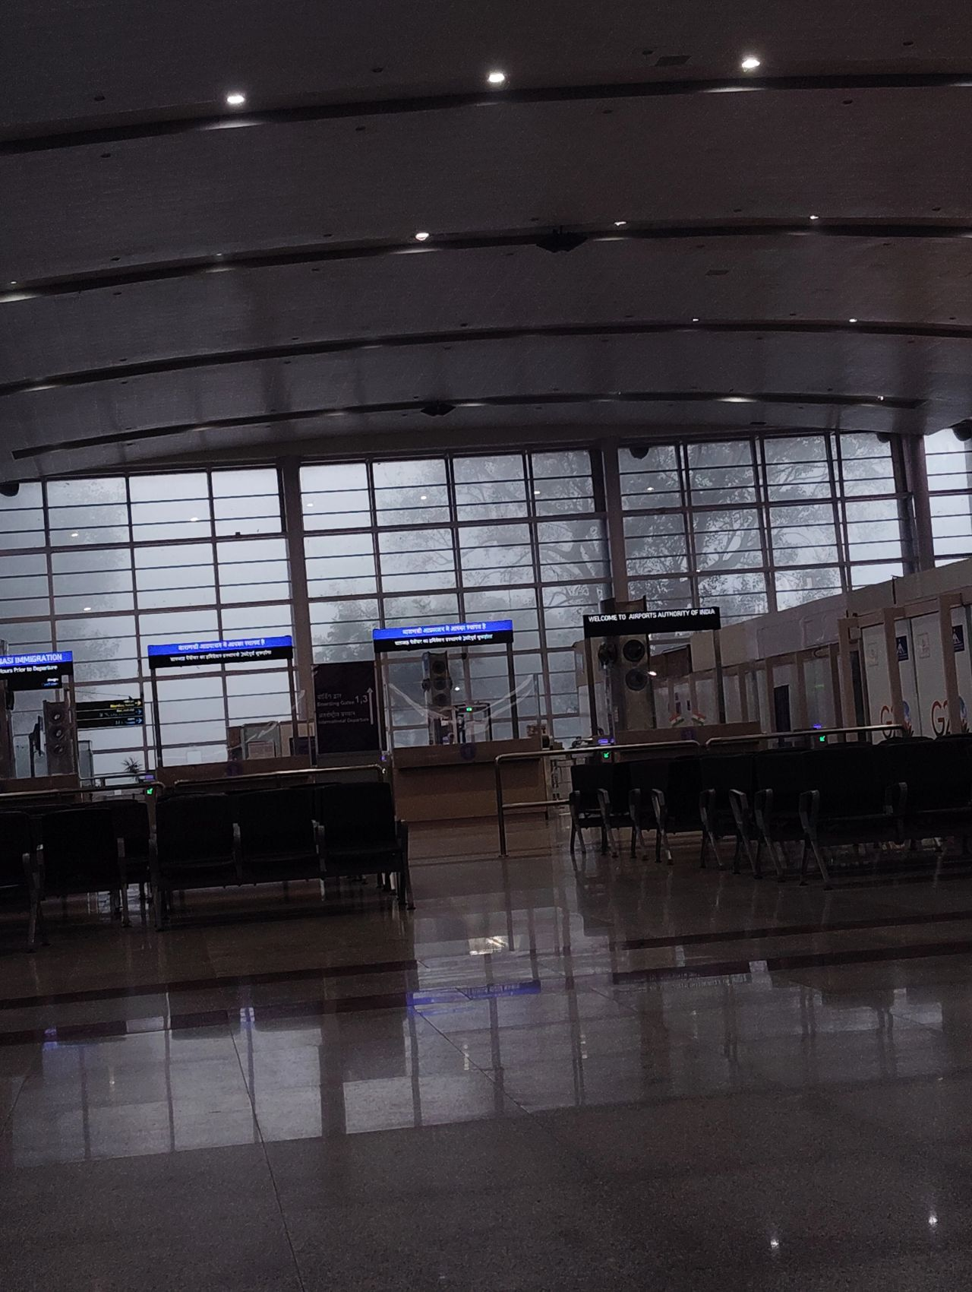
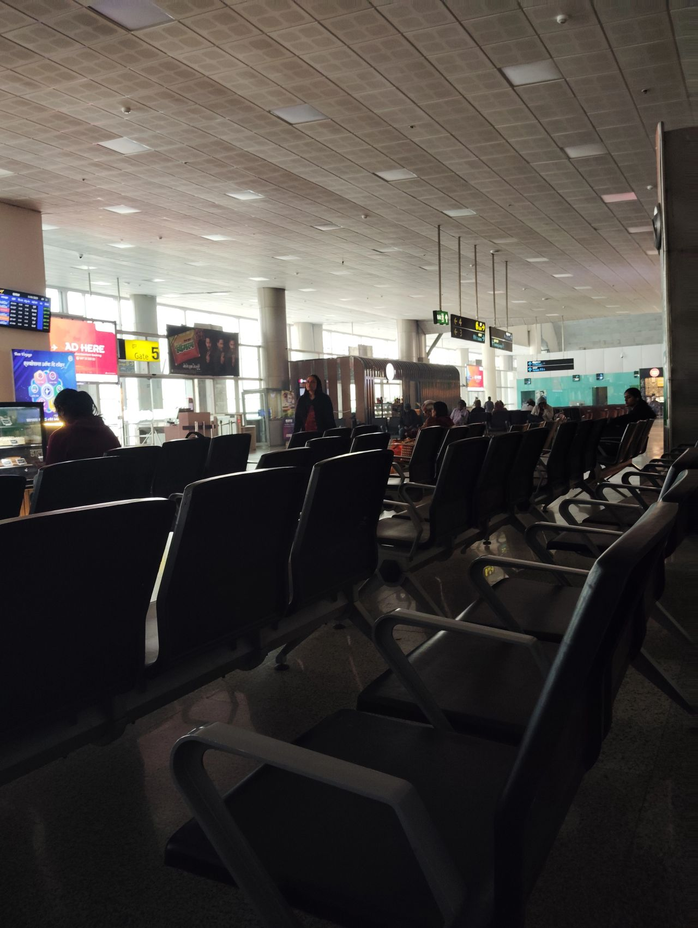

I was in Std 11th when I flew for the first time.

Out of necessity.

Your boy was down with dengue and was pretty weak to travel via train from Patna to Erode for CBSE nationals.

The team couldn't go without the captain, so the team decided on flights.

Part of it was paid by my father, part of it reimbursed by school.

The next time I could fly was 5 years later.

With my first internship money to see my long distance partner. Dumb. Worth it.

My Nani always wanted to fly, but never could.

She was too sick by the time the grandchildren were earning enough to afford a trip for her.

The ability to fly remains a premium desire for most of the lower middle class families.

So every time I'm at the airport, despite the fact that It is relatively more affordable for me-

I'm still looking for an experience that I could never have at railway stations.

And oh boy do I get it.

And I hate it.

Dark patterns ka baap hai airport.

Railway station pe neend aae, chadhar bichao so jaao.

Idhar neend aae, jaake tim hortons ko 700 rupay deke aao.

Chadar bicha nahi sakte, cannot look straight from de-haat-land.

Sone ye denge nahi. Anti sleep chairs bana rakhi hain.

Desi log ko maloom hai ye sab the moment they check in.

Sab golmal hai.

But the discomfort is universal, bad enough in the UK for psychologists to study it reverse engineering the motivations.

An article in The Sun reports-

"Psychologist Robert Sommer previously suggested that the seats were designed to be "sociofugal" which means they discourage social interaction and also discourage stillness for long term - making people more likely to go to the shops and cafes and spend money instead."

Jai ho capitalism mayyia ki. Dear meritocratic friends, as is their argument for everything else, would say- then why go to an airport if you can't afford 700 coffee.

I can. Insta story ke lie. Neend bhagane ke lie nahi. Wo amrika culture hai 😤

Advice for product managers obsessed with removing friction - some frictions are good for business.

But please in pure LinkedIn fashion, the next time you're at an airport, DO NOT find inspiration in these godforsaken chairs.

Ye wala smooth and sleepable chahie.

Flight miss nahi hogi meri mai alarm laga lunga, please.

Railway station experience ko hi upgrade karke dedo.

Log bahut khush honge.

tldr:

Man annoyed at the airport chairs, while also knowing "It just works".

Trying to replicate and upgrade the railway station experience will break airports.

There's a reason airport fashion exists and railway fashion doesn't.

Everyone successful must look alert and uptight all the time right? or have some finesse at the bare minimum. That's the symbol of a "highly functional society" out here.

Warna laao launge ke paise. Chup ke karo aaram.

